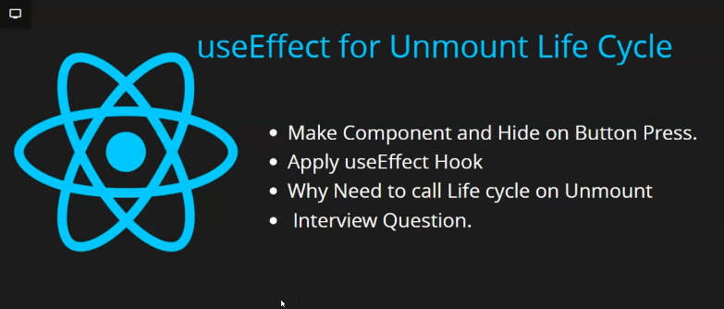

In this lesson we will learn about How to use useEffect with unmount lifecycle in react when unmount lifecycle is called was told by the Teacher that when we make component hide or detach it from our React native UI then our unmount lifecycle methods are called So Iin this lesson we will see How to use useEffect that it will be called with unmount lifecycle. You can ask question here that if we are hiding a component. By unmount we mean hide from UI then why it is necessary to call lifecycle method when it is hidden from the UI what is its use neither we are going to call API there

Not writing any logic neither write color (who knows) but still why we will call useEffect Teacher will give its perfect example but for now our cover points. We will understand that how useEffect work with unmount lifecycle later teacher will give us some satisfying example which will help us in interviews and you can make your friends understand so first of all we will make component and then hide and show a component and then we will apply useEffect about How it is being called and then Teacher will give us actual example and at last will discuss interview question

Now make a Button component and import it and then add it and then we give its title that is Toggle And now we make a component named student .We add view and inside it text and then add style and such that font is of 30 size. And color is red and will display a student. Now our code will look like below

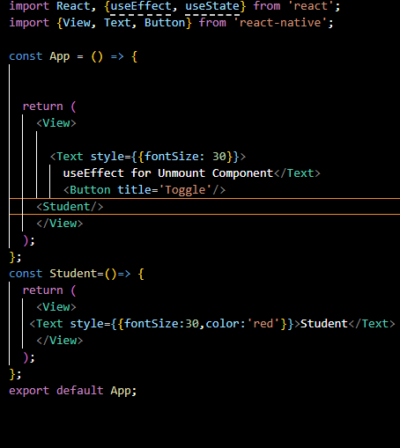

Now our output like below

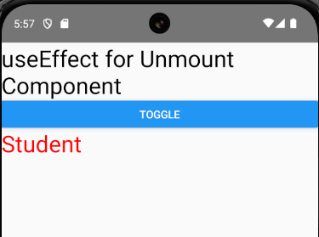

Now we make a state that will help us in toggling between show or hide If you want to see in detail then you can see the last lesson because Teacher is going to do now very fast

Now we add onPress in Button and inside this onPress callback use the shoe updation method and pass it opposite of show so the we can toggle it between hide and show component.

3:23

And now if show is true then Student component will be shown otherwise nothing will be shown

Now as we hide it then the Student will be unmounted smf then unmounted lifecycle will look like below



Our code will look like below

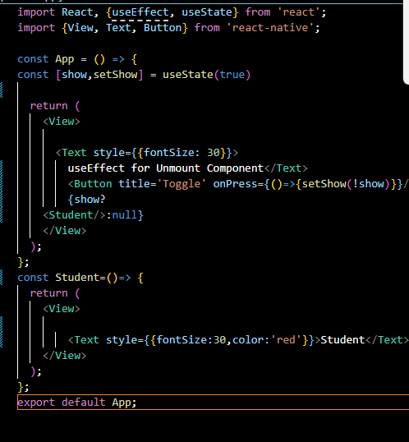

Now we write useEffect in Student in the code below

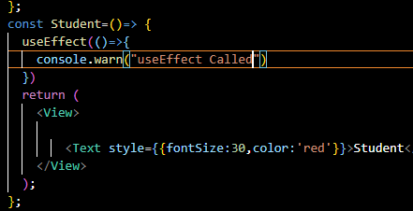

If you are using useEffect normal then it will not work for unmounting phase

It will be called when our student become visible

Now when we reload the app then the Student is visible by default this warning will be shown as marked below

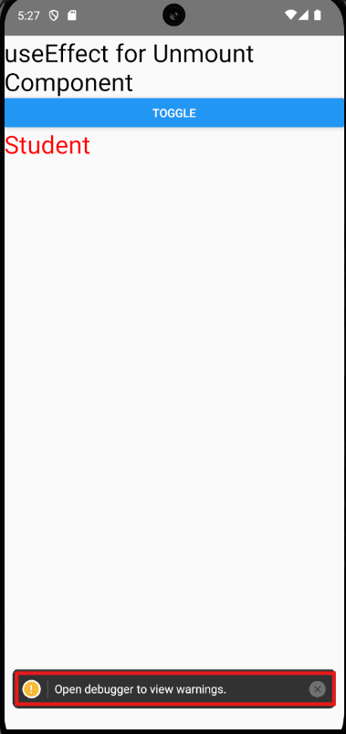

Now you will see that when the Student component get mounted then the warning will be shown and when it is unmounted then it is not called I cannot see because I think after the one warning upcoming same warning is shown in debugger(I don’t know why)

Do what you need top do is nothing just make one callback inside the useEffect and return it And inside it print the warning Now when the Student get unmounted then this useEffect will be called

As shown below

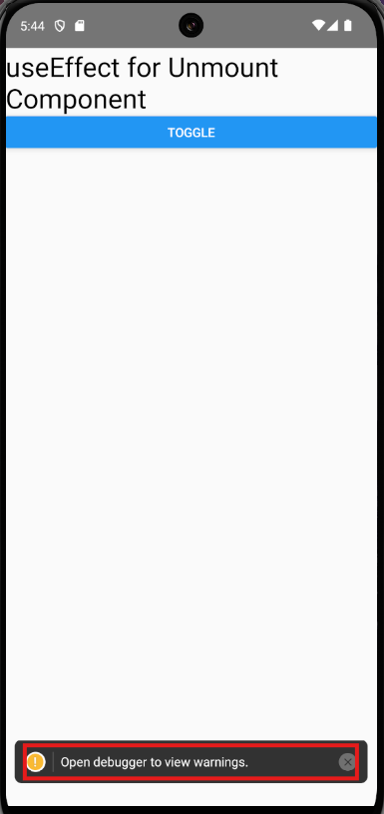

Now what is its use . It runs when component is hidden then what do we get by calling because we don’t want to call api even if we do it then our component is hidden and there is no benefit as it is hidden it what is its use

Now Teacher will show its use that is take timer

So for that we call set Interval in the Student component and we call the callback passed inside the setInterval after every 2 second. Now the callback will print a warning that is “Timer called”

Now our code will look like below

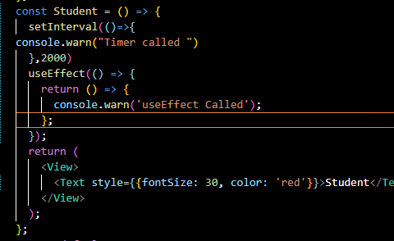

Now in output after every 2 second warning will be shown in debugger as shown below



Now what we do is remove the component by toggle then still the callback that was passed in the setInterval will be called as shown below.



Now why it is happening the reason is that these settimeout and setInterval are called in background UI works differently inside javascript but javascript engine is such that these time delaying things work in background even if you remove the component from UI then these time interval will work in background Now suppose the setInterval works in 2 second Now someone open your app and leave it as it is open then now whatever work is going on. Now whatever work is going on like calling on API Now whatever work is in interval will keep going on and it make keep eating space(id you are storing something after every regular interval). It will drain battery in mobile if we talk about web then browser get hanged and it will take more space in the computer so it is important to remove them when a component get unmounted.

8:03

Now how to remove the setInterval To do that we take the setInterval to a variable named timer and we keep refreshing timers get stored in the background in main memory (maybe talking about call back passed in the setInterval) Now we reload then the warning is still getting printed

Now just in return of useEffect pass the callback containing clearInterval method and then inside that method pass the timer variable (this contains maybe the address of timer)

Now by default when the screen gets reloaded the console.warn will be shown repeatedly after 2 second (they may come faster because you toggle mount and unmount multiple points an d there are multiple timers or maybe when we update our code then component get unmounted to mount again after updation happened in the UI(who knows))

Now when we hide the Student component then now no warning will be shown now after 2 seconds



It is because as we unmount our component then serInterval get cleared

Now this timer when you don’t not need it then it will not take your memory or neither slow your mobile or drain memory This is the actual use and it is often asked in Interviews Never forget this question before interviews. There are high chances that of you are being asked about lifecycle question then this question will be asked